Training Session Notes

Title: Jupiter Engine Overview

Author: David L. Koenig
Initial Date: 11/04/2002
- Basic Architecture
- Objects
- Interfaces

Basic Architecture

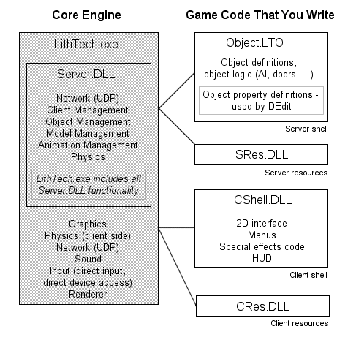

Engine Files
Name | Description
Lithtech.exe | Core engine binary.
LTMsg.dll | Engine error messages. (for localization)
SndDrv.dll | Sound manager.
Engine.rez | Basic resources used by the engine. Contains the console font.
Server.dll | Stand alone server DLL.

Game Files
Name | Description
Cres.dll | Client-side string tables for localization.
CShell.dll | Client-side game code.
Object.lto | Server-side game code (DLL).
Sres.dll | Server-side string tables for localization.
ClientFX.fxd | ClientFX DLL.

Client/Server

Jupiter is built on a Client/Server architecture. In a single player game, the game server resides on the same machine as the client, and is started “behind the scenes” when StartGame is called using STARTGAME_NORMAL as the type.

Objects

Game code objects derive from BaseClass.

Engine Object Types
Type | Description
OT_NORMAL | This object type is invisible, and is not transferred to the client automatically. Normal uses for this object are things such as waypoints, or anything that needs a rotation and position, without the need to be visible, or have a model or world geometry associated with it.
OT_MODEL | This object type is used when you want to load a model. Generally you associate code with the model, for thing such as projectiles or player characters.
OT_WORLDMODEL | This object type has world geometry associated with it. Examples might be, doors, triggers, or breakable lights.
OT_SPRITE | This object type is used when you want to load a sprite (billboard) object. You might do this for bullet marks, or flames.
OT_LIGHT | This object type is a dynamic light. You might create one of these for special effects. Perhaps your character is holding a torch in which the light source is to follow that character around.
OT_CAMERA | This object type represents a 3D camera object. You must have at least one of these objects created on the client-side in order to view a 3D world.
OT_PARTICLESYSTEM | This object is a standard particle system. This object is rarely used. Generally ClientFX is used for placing particle systems within a world.
OT_POLYGRID | This object type represents a grid of vertices, which can be manipulated at runtime to create dynamic effects such as advanced water systems.
OT_LINESYSTEM | This object type allows you to create lines in 3D space. The most common application of this object is for debugging purposes. For example you could create a box object to represent the dimensions of an object in the world.
OT_CONTAINER | This object type is very similar to the OT_WORLDMODEL object. The difference is that this object is meant to contain other objects. Generally this object is used for trigger objects, or water volumes which need to affect the physics of player objects.
OT_CANVAS | This object type is unique in that it allows you to specify a callback function, which is called during rendering to allow you to render custom objects. This is most often used in conjunction with the ILTDrawPrim interface.
OT_VOLUMEEFFECT | This object type is used for specifying the bounding dimensions of a particle system effect. Example: Snow or Rain.

Interfaces

Example: define_holder(ILTDrawPrim, g_pLTDrawPrim);

Interfaces
Name | Description
ILTClient | Main client-side interface for talking to the engine. (g_pLTClient)
ILTServer | Main server-side interface for talking to the engine. (g_pLTServer)
ILTDrawPrim | Used for drawing arbitrary polygons. Ex: Menu/UI & Special effects.
ILTCommon | Miscellaneous. Contains functions for creating networking messages, and changing object flags.
ILTDirectMusic | Provides an interface to DirectMusic.
ILTFontManager | Provides several font support functions. Supports Bitmap fonts and Vector (True Type) fonts.
ILTVideoMgr | Play video media files through DirectShow.
ILTMessage | Messaging functions.
ILTModel | Provides functions for manipulating models and animations.
ILTPhysics | Provides common physics functions. (Get/Set velocity, Get/Set bounding dims, Get/Set friction)
ILTSoundMgr | Provides functions for playing sound effects. (Wav files. Supports EAX 2.0)
ILTSpriteControl | Provides function for manipulating sprites. Useful for creating a class for managing interface sprites. (Get anim position, number of frame, flags)
ILTStream | Provides functions for reading/writing to disk. Must use this if loading a file inside a REZ file.
ILTTexInterface | Provides functions for manipulating textures in game code.

